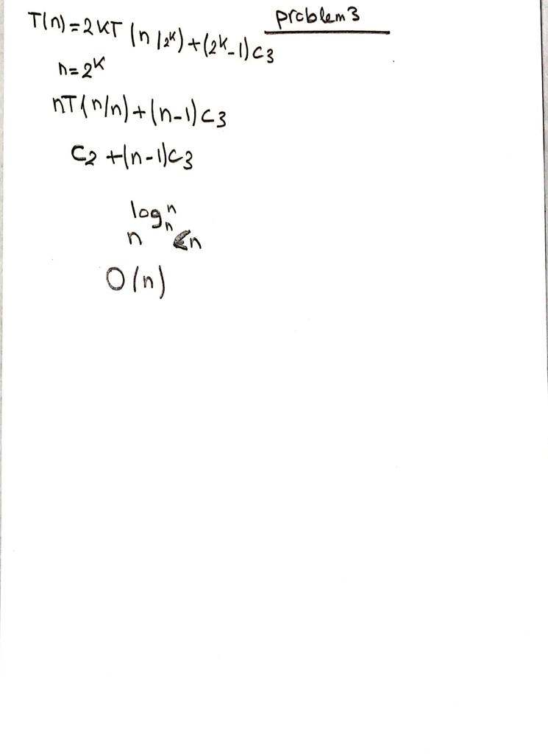the time complexity for problem 5 is O(N^3)